**Tables:**

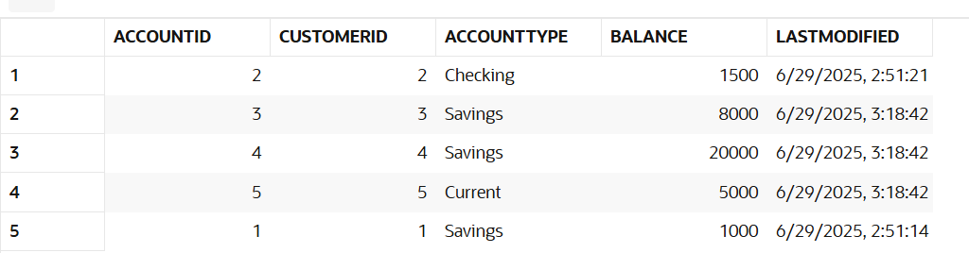

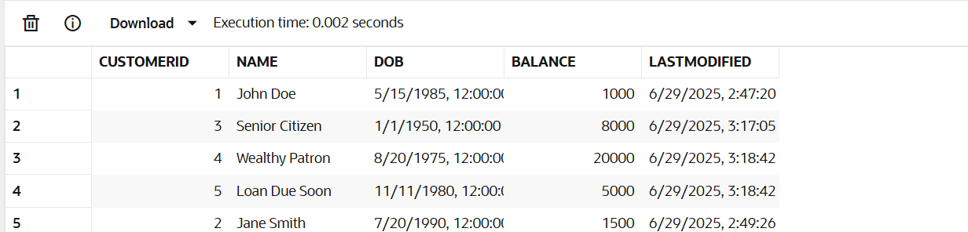

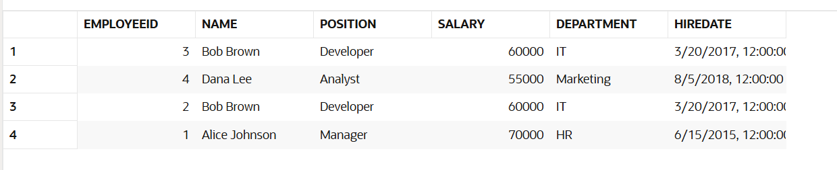

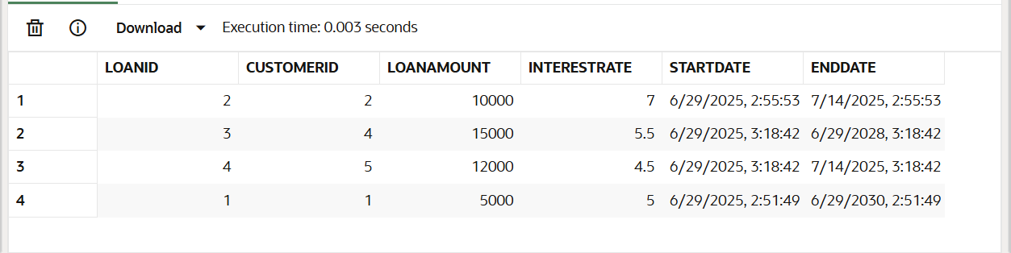

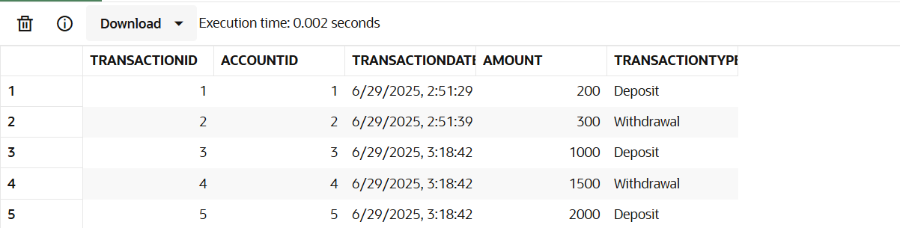

**Scenario 1: Process Monthly Interest for All Savings Accounts**

**PL/SQL Code:**

CREATE OR REPLACE PROCEDURE ProcessMonthlyInterest IS

BEGIN

    FOR acc IN (

        SELECT AccountID, Balance

        FROM Accounts

        WHERE AccountType = 'Savings'

    ) LOOP

        UPDATE Accounts

        SET Balance = Balance + (acc.Balance * 0.01)

        WHERE AccountID = acc.AccountID;

    END LOOP;

END;

BEGIN

    ProcessMonthlyInterest;

END;

SELECT * FROM Accounts;

**Output:  
 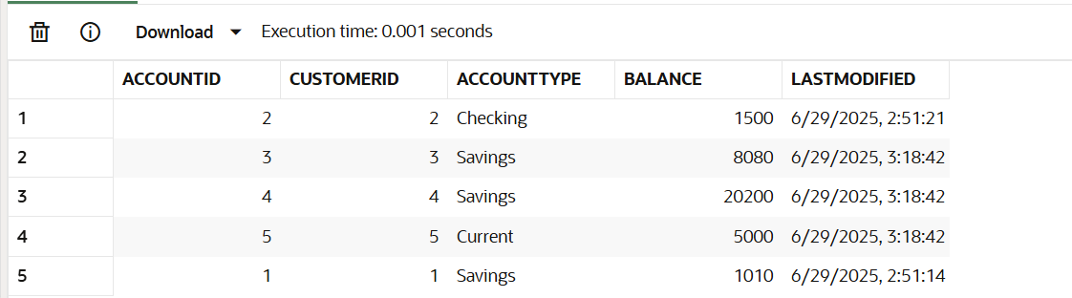**

**Scenario 2: Bonus for Employees by Department**

**Code:**

CREATE OR REPLACE PROCEDURE UpdateEmployeeBonus (

    dept_name IN VARCHAR2,

    bonus_percent IN NUMBER

) IS

BEGIN

    UPDATE Employees

    SET Salary = Salary + (Salary * (bonus_percent / 100))

    WHERE Department = dept_name;

END;

BEGIN

    UpdateEmployeeBonus('IT', 10);

END;

SELECT * FROM Employees;

**Output:**

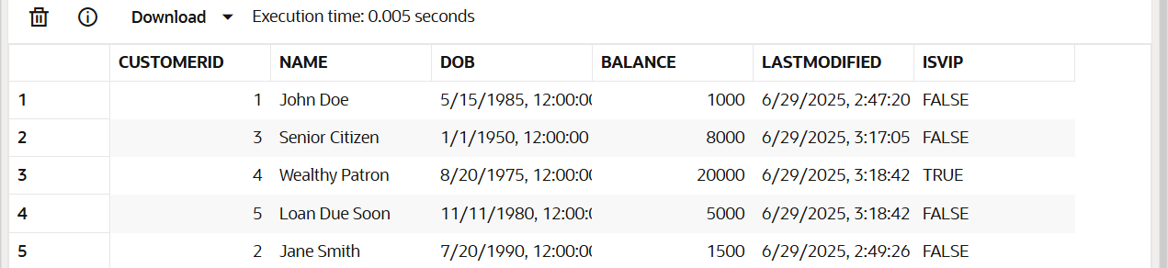

**Scenario 3: Send Reminders for Loans Due in Next 30 DaysCode:**

BEGIN

FOR loan_rec IN (

SELECT LoanID, CustomerID, EndDate

FROM Loans

WHERE EndDate <= SYSDATE + 30

) LOOP

DECLARE

cust_name VARCHAR2(100);

BEGIN

SELECT Name INTO cust_name

FROM Customers

WHERE CustomerID = loan_rec.CustomerID;

DBMS_OUTPUT.PUT_LINE('Reminder: Loan ' || loan_rec.LoanID ||

' for customer ' || cust_name ||

' is due on ' || TO_CHAR(loan_rec.EndDate, 'YYYY-MM-DD'));

END;

END LOOP;

END;  
  
**Output:**